**Module 11: Protecting and Sharing the work book, Use Macros to Automate Tasks**

Protecting a workbook with a password

Allow user to edit ranges

Track changes

Working with Comments

Insert Excel Objects and Charts in Word Document and Power point

Presentation.

Creating and Recording Macros

Assigning Macros to the work sheets

Saving Macro enabled workbook

# The Document Inspector

Whenever you create or edit a workbook, certain **personal information** may be added to the file automatically. You can use the Document Inspector to remove this information before sharing a workbook with others.

Because some changes may be permanent, it's a good idea to save an additional copy of your workbook before using the Document Inspector to remove information.

To use the Document Inspector:

Click the **File** tab to access **Backstage view**.

From the **Info** pane, click **Check for Issues**, then select **Inspect** **Document** from the drop-down menu.

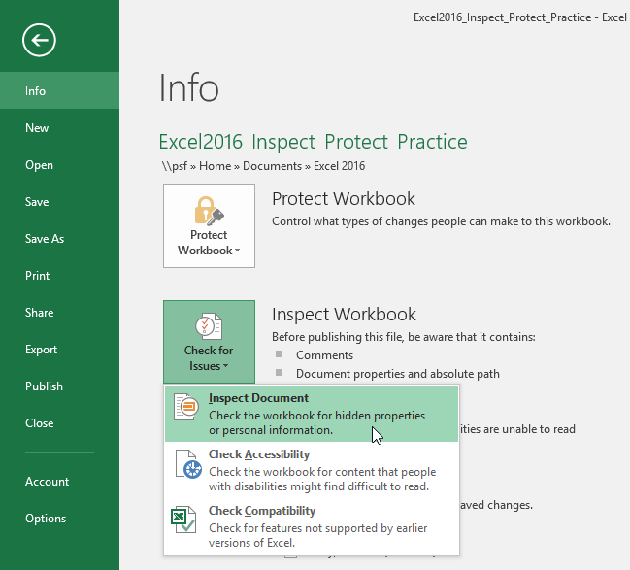

You may be prompted to save your file before running the **Document Inspector**.

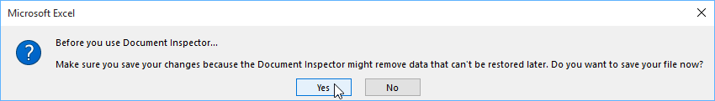

**Document Inspector**will appear. Check or uncheck boxes, depending on the content you want to review, then click **Inspect**. In our example, we'll leave everything selected.

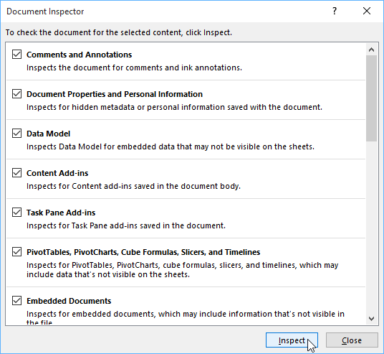

The **inspection** **results** will appear. In our example, we can see that our workbook contains comments and some personal information, so we'll click **Remove All**on both items to remove this information from the workbook.

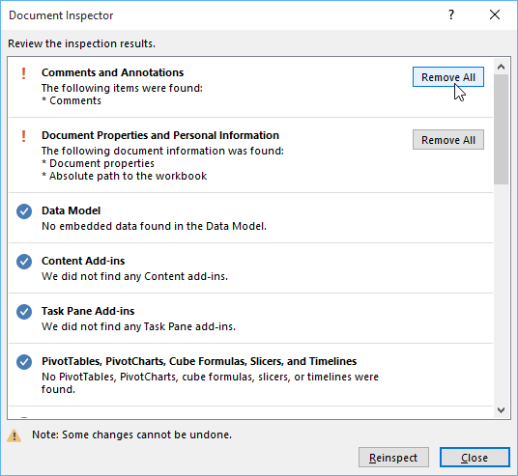

When you're done, click **Close**.

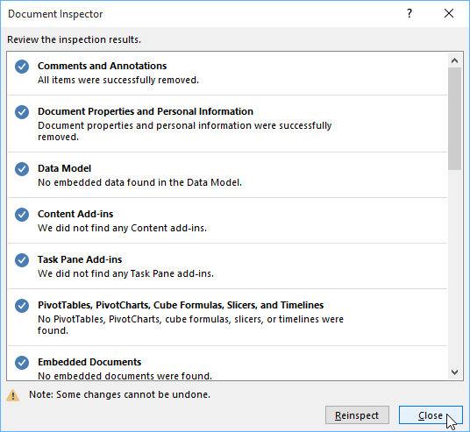

# Protecting a workbook with a password

By default, anyone with access to your workbook will be able to open, copy, and edit its content unless you **protect** it. There are several ways to protect a workbook, depending on your needs.

To protect your workbook:

1. Click the **File** tab to access **Backstage view**.
2. From the **Info** pane, click the **Protect Workbook** command.
3. In the drop-down menu, choose the option that best suits your needs. In our example, we'll select **Mark** **as Final**. Marking your workbook as final is a good way to discourage others from editing the workbook, while the other options give you even more control if needed.

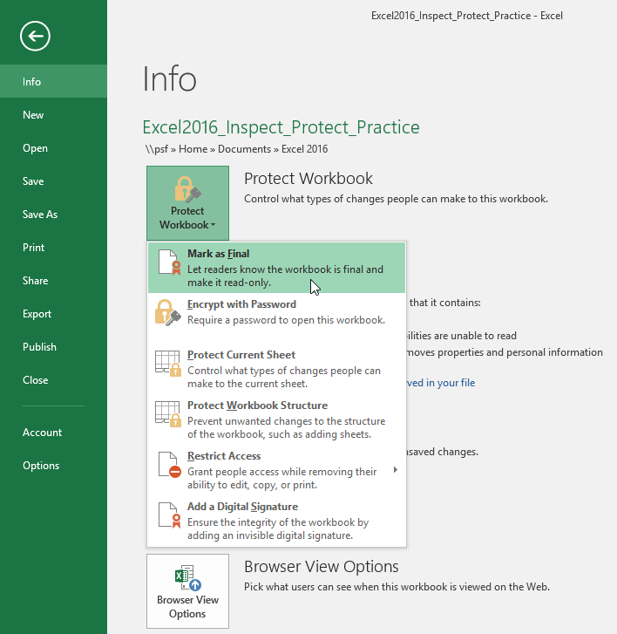

1. A dialog box will appear, prompting you to save. Click **OK**.

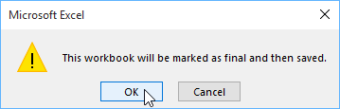

1. Another dialog box will appear. Click **OK**.

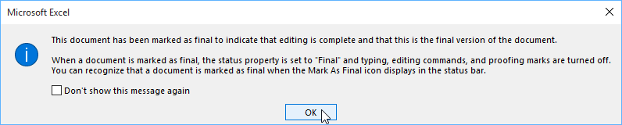

1. The workbook will be marked as final.

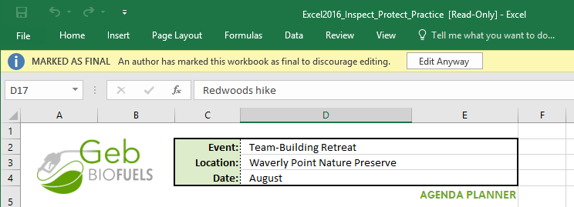

Marking a workbook as final will not prevent others from editing it. If you want to prevent people from editing it, you can use the **Restrict Access** option instead.

Challenge!

1. Open our [**practice workbook**](https://media.gcflearnfree.org/content/5c0984ee77c05003547285c0_12_06_2018/excel_inspectprotect_practice.xlsx).
2. Use the **Document Inspector** to check the workbook and **remove** anything it finds.
3. **Protect** the workbook by **Marking As Final**.
4. When you're finished, your workbook should look something like this:

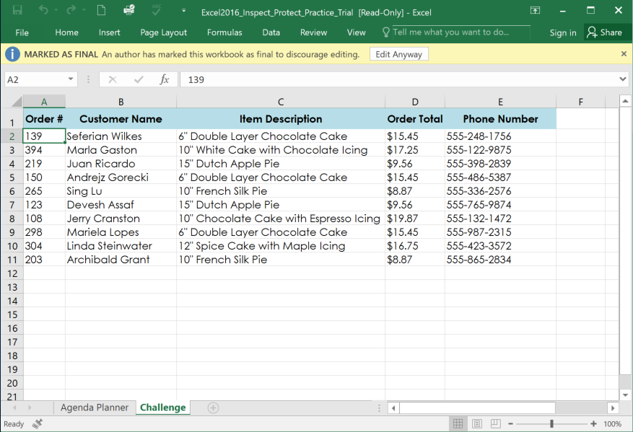

# Allow user to edit ranges

1. Select one range.

2. Set password for that range

[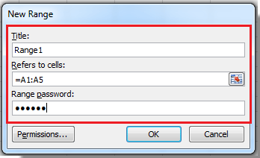](https://filestore.community.support.microsoft.com/api/images/c0625fb2-a506-4fda-af7b-5febfa778f77?upload=true&fud_access=wJJIheezUklbAN2ppeDns8cDNpYs3nCYjgitr%2BfFBh2dqlqMuW7np3F6Utp%2FKMltnRRYFtVjOMO5tpbpW9UyRAwvLeec5emAPixgq9ta07Dgnp2aq5eJbnfd%2FU3qhn54rK6e2JuhHmHaZmPDXVfWAunsLSD5lkwvvf%2BfZn7zlhFkpNROZCsX70T8cPZibGX9pp48Dm693mCeEF7m4tqqneSBFoIsh0a%2BPtJZGm9H%2BKWxPOqSR%2Be3XE24bAHs%2BwunOOFSje%2FjQRMQ9rI1YeLfIPB54fjEMYqEGpFTQJ%2FBCWdXlT3OgsVVMvuirRQ4NExCDHUwLDUrrJ32%2BMBLxuhX9RCOX92ZEbxiv9RMWNpPNbahyUXxkcCDrZalWPHBGt3YjfyK65rJEWpTWHXQXEN0yIbdy3d7hRelDAIx7LbCmb8%3D)

3. Set permission

[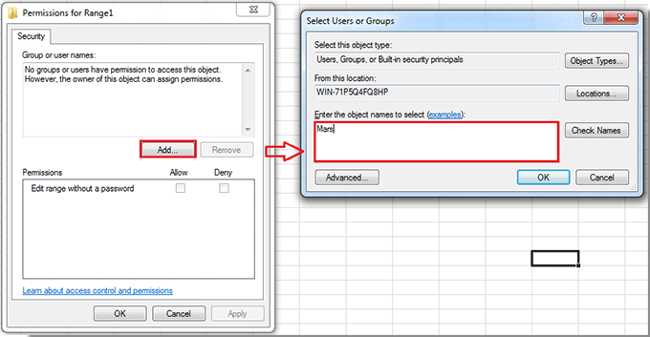](https://filestore.community.support.microsoft.com/api/images/3ab26b27-58e1-4c4e-ad65-1eb2f5b86520?upload=true&fud_access=wJJIheezUklbAN2ppeDns8cDNpYs3nCYjgitr%2BfFBh2dqlqMuW7np3F6Utp%2FKMltnRRYFtVjOMO5tpbpW9UyRAwvLeec5emAPixgq9ta07Dgnp2aq5eJbnfd%2FU3qhn54rK6e2JuhHmHaZmPDXVfWAunsLSD5lkwvvf%2BfZn7zlhFkpNROZCsX70T8cPZibGX9pp48Dm693mCeEF7m4tqqneSBFoIsh0a%2BPtJZGm9H%2BKV7Kzv63WYjq1nDuMd4gEyRC7k5R8DFWnRUW3Wko9ALv6IF1xSr1kkaDKh48i6MVRtFeTuFMQOKwnv0aIqHNC1SlBh1E1OhxvxMaFzQl0LhFKxmSfXgW9twwUoCsNksRXcUBzwzySxd%2BVz6VVyVg7navwzR8t94wDcuRtafWrjgetRucjLJ7%2BcF9ehMty8cBLE%3D)

4. Define whether this user needs the password to edit the range or not

[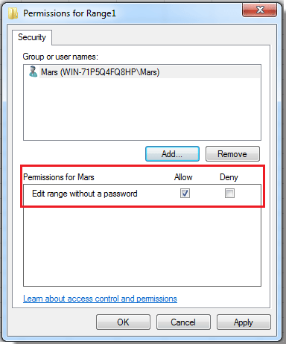](https://filestore.community.support.microsoft.com/api/images/901eb42c-67d6-44e5-8b4a-ac7491d01b3b?upload=true&fud_access=wJJIheezUklbAN2ppeDns8cDNpYs3nCYjgitr%2BfFBh2dqlqMuW7np3F6Utp%2FKMltnRRYFtVjOMO5tpbpW9UyRAwvLeec5emAPixgq9ta07Dgnp2aq5eJbnfd%2FU3qhn54rK6e2JuhHmHaZmPDXVfWAunsLSD5lkwvvf%2BfZn7zlhFkpNROZCsX70T8cPZibGX9pp48Dm693mCeEF7m4tqqneSBFoIsh0a%2BPtJZGm9H%2BKWtG%2Bcoe6wo5yQvnrrMy0KypUMT2%2FMieVDZWQsTSp6PvG6D0WmUNfsGQ7ssGUrJYyvCLdf%2FrA3si5np5SIR1n%2BA8nv2IniJTruaWR%2FTr%2BqRcZHCFbxCkXhgoZvtzQUS1kng03fzLJgYwaCrRIQU7xC%2Fowe95sjmDAuJPEEhHesgaqGPbgzHieeWNBklomILi%2BI%3D)

5. Repeat steps for each range.

6. Protect sheet.

[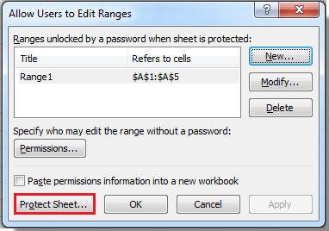](https://filestore.community.support.microsoft.com/api/images/eb53a15d-3dea-4345-9041-21acc5faec5d?upload=true&fud_access=wJJIheezUklbAN2ppeDns8cDNpYs3nCYjgitr%2BfFBh2dqlqMuW7np3F6Utp%2FKMltnRRYFtVjOMO5tpbpW9UyRAwvLeec5emAPixgq9ta07Dgnp2aq5eJbnfd%2FU3qhn54rK6e2JuhHmHaZmPDXVfWAunsLSD5lkwvvf%2BfZn7zlhFkpNROZCsX70T8cPZibGX9pp48Dm693mCeEF7m4tqqneSBFoIsh0a%2BPtJZGm9H%2BKUWpir56mrEtMDc2r47OqylKUqkoJXvUFKeLaJf1ovb4fC10PG3UeQjiH3tHNoaeBApaJ09G67yZG9bT5WhP2mKPUwJgKk2bk4kno4UeszymaQZ87VnxCllaDl75wE6%2F4K6OfOuaQ0vZ7RLVLKRzUWJC3erAFNFfhhMxkpntMOZJlVQIt8p52gAjxR%2BbcBNqDk%3D)

# Understanding Track Changes

**Alert! The Track Changes command has been removed from the Review Tab in Excel 2016.**

When you turn on the **Track Changes** feature, every cell you edit will be **highlighted** with a unique border and indicator. Selecting a marked cell will show the details of the change. This allows you and other reviewers to see what's been changed before accepting the revisions permanently.

In the image below, each edited cell has a blue border and a small triangle in the upper-left corner.

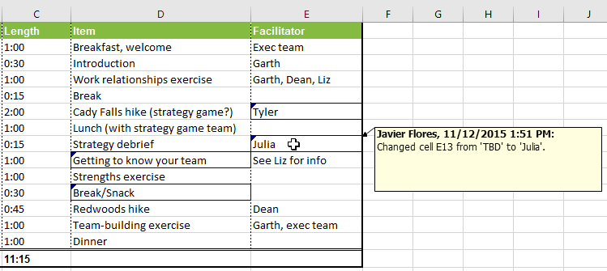

There are some changes Excel **cannot** track. Before using this feature, you may want to review Microsoft's list of [**changes that Excel does not track or highlight**](http://office.microsoft.com/en-us/excel-help/track-changes-in-a-shared-workbook-HP010342961.aspx#BM7).

You cannot use Track Changes if your workbook includes **tables**. To remove a table, select it, click the **Design** tab, then click **Convert to Range**.

To turn on Track Changes:

1. From the **Review** tab, click the **Track Changes**command, then select **Highlight Changes** from the drop-down menu.

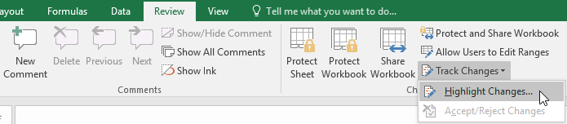

1. The **Highlight Changes** dialog box will appear. Check the box next to **Track changes while editing**. Verify that the box is checked for **Highlight changes on screen**, then click **OK**.

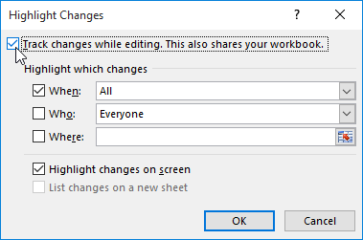

1. If prompted, click **OK** to allow Excel to save your workbook.

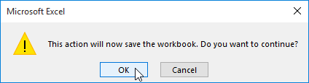

1. Track Changes will be **turned on**. A**triangle**and **border** **color**will appear in any cell you edit. If there are multiple reviewers, each person will be assigned a different color.
2. Select the edited cell to see a summary of the tracked changes. In our example below, we've changed the content of cell D14 from **?** to **Getting to know your team**.

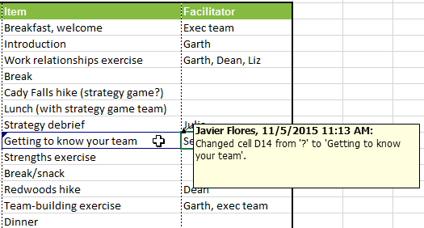

When you turn on Track Changes, your workbook will be **shared** automatically. Shared workbooks are designed to be stored where other users can access and edit the workbook at the same time, such as a network. However, you can also track changes in a local or personal copy, as seen throughout this lesson.

To list changes on a separate worksheet:

You can also view changes on a new worksheet, sometimes called the **Tracked Changes history**. The history lists everything in your worksheet that has been changed, including the **old value** (previous cell content) and the **new value** (current cell content).

1. **Save** your workbook.
2. From the **Review** tab, click the **Track Changes**command, then select **Highlight** **Changes**from the drop-down menu.



1. The **Highlight Changes** dialog box will appear. Check the box next to **List changes on a new sheet**, then click **OK**.

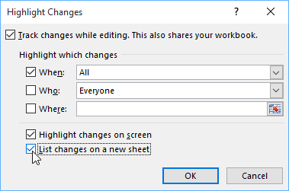

1. The tracked changes will be listed on their own worksheet, called **History**.

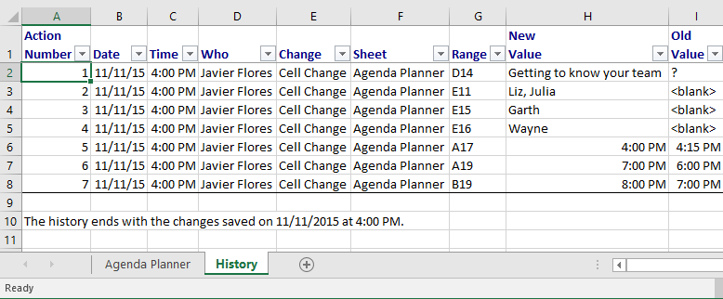

To **remove** the History worksheet from your workbook, you can either **save** your workbook again or uncheck the box next to **List changes on a new sheet** in the **Highlight** **Changes** dialog box.

Reviewing changes

Tracked changes are really just **suggested** changes. To become permanent, the changes must be **accepted**. On the other hand, the original author may disagree with some of the tracked changes and choose to **reject** them.

To review tracked changes:

1. From the **Review** tab, click **Track Changes**, then select **Accept/Reject Changes** from the drop-down menu.

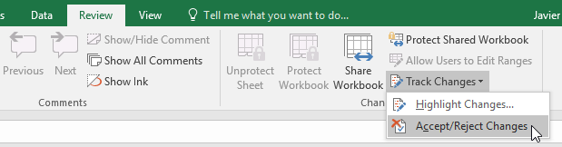

1. If prompted, click **OK** to save your workbook.
2. A dialog box will appear. Make sure the box next to the **When:** field is checked and set to **Not yet reviewed**, then click **OK**.

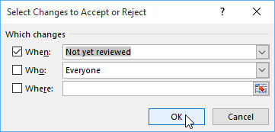

1. A dialog box will appear. Click **Accept** or **Reject** for each change in the workbook. Excel will move through each change automatically until you have reviewed them all.

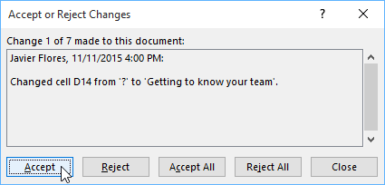

1. Even after accepting or rejecting changes, the tracked changes will still appear in your workbook. To remove them completely, you'll need to **turn off** Track Changes. From the **Review** tab, click **Track Changes**, then select **Highlight Changes**from the drop-down menu.

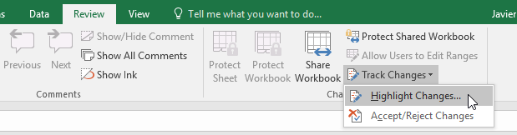

1. A dialog box will appear. Uncheck the box next to **Track changes while editing**, then click **OK**.

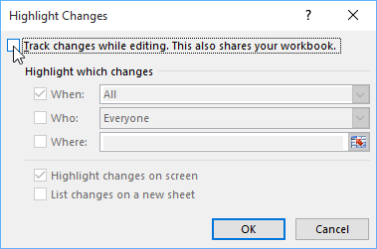

1. Click **Yes** to confirm that you want to turn off Track Changes and stop sharing your workbook.

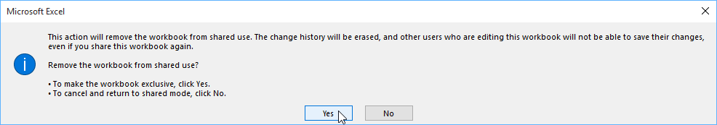

To accept or reject all changes at once, click **Accept All** or **Reject All** in the Accept or Reject Changes dialog box.

Turning off Track Changes will remove any tracked changes in your workbook. You will not be able to view, accept, or reject changes; instead, all changes will be accepted **automatically**. Always review the changes in your worksheet before turning off Track Changes.

Comments

Sometimes you may want to add a **comment** to provide feedback instead of editing the contents of a cell. While often used in combination with Track Changes, you don't necessarily need to have Track Changes turned on to use comments.

To add a comment:

1. Select the **cell** where you want the comment to appear. In our example, we'll select cell **D17**.

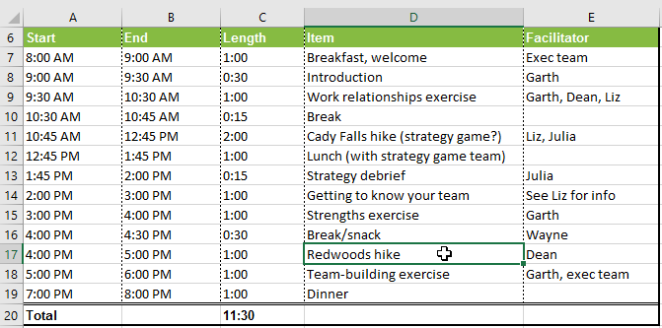

1. From the **Review** tab, click the **New Comment** command.

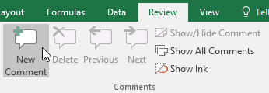

1. A **comment box** will appear. Type your comment, then click anywhere outside the box to close the comment.

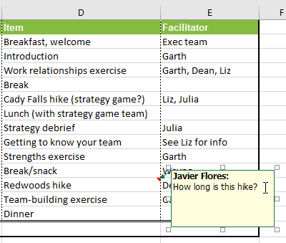

1. The comment will be added to the cell, represented by the **red triangle** in the top-right corner.

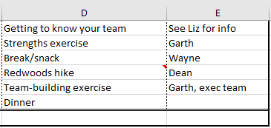

1. Select the cell again to view the comment.

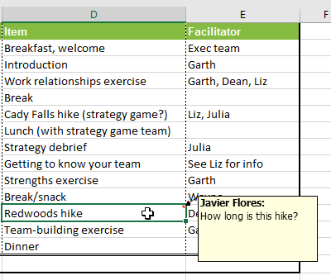

To edit a comment:

1. Select the **cell** containing the comment you want to edit.
2. From the **Review** tab, click the **Edit Comment** command.

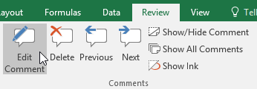

1. The **comment box** will appear. Edit the comment as desired, then click anywhere outside the box to close the comment.

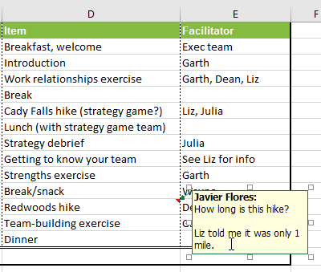

To show or hide comments:

1. From the **Review** tab, click the **Show All Comments** command to view every comment in your worksheet at the same time.

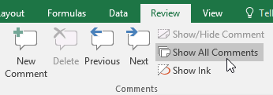

1. All comments in the worksheet will appear. Click the **Show All Comments** command again to hide them.

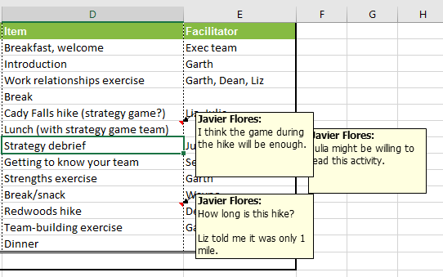

You can also choose to show and hide individual comments by selecting the desired cell and clicking the **Show/Hide Comment** command.

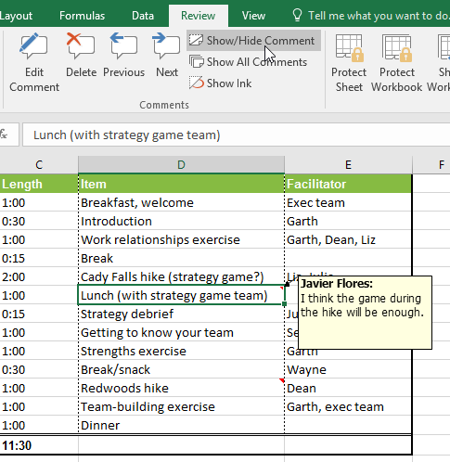

To delete a comment:

1. Select the **cell** containing the comment you want to delete. In our example, we'll select cell **E13**.

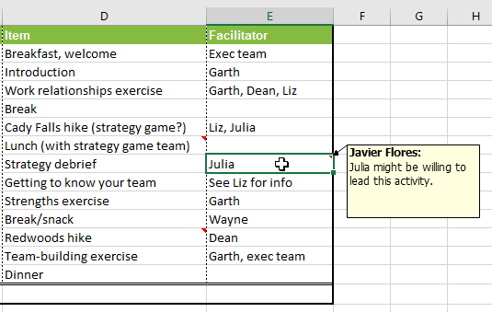

1. From the **Review** tab, click the **Delete** command in the **Comments** group.

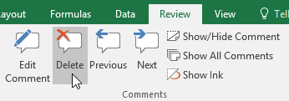

1. The comment will be deleted.

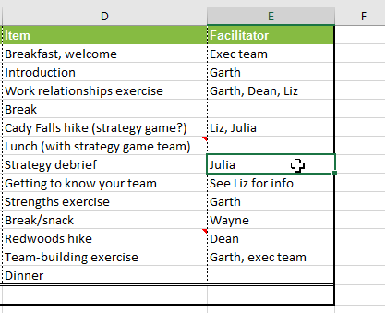

Challenge!

1. Open our [**practice workbook**](https://media.gcflearnfree.org/content/563790ac927faf14d04cadec_11_02_2015/excel2016_trackchangescomments_practice.xlsx).
2. Turn on **Track Changes**.
3. Replace the value in cell **D14** with **Rope Bridge Activity**.
4. Change cell **E15** to say **Julia**.
5. **Save** your workbook.
6. **List changes**on a **new sheet**. After you do this, the worksheet should look like this:

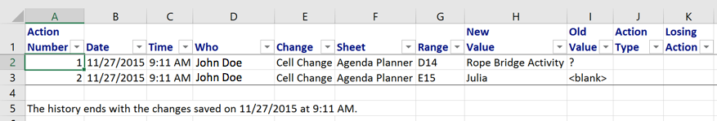

1. Return to the **Agenda Planner** tab.
2. Add a **comment** to cell **E16** that says **snacks will be provided by the exec team**.
3. When you're finished, your workbook should look like this:

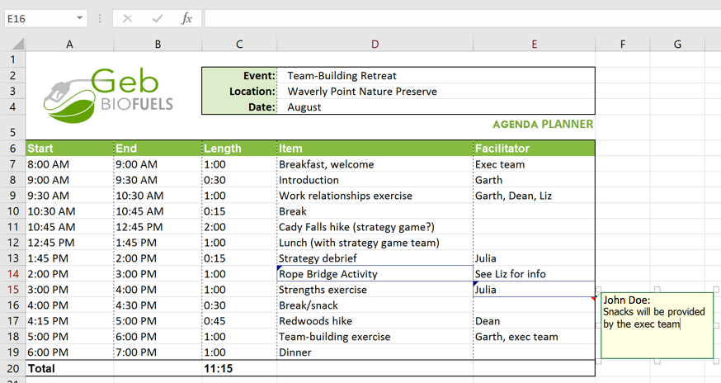

1. **Accept All Changes**, then **turn off** Track Changes.

Comments

One way to collaborate on a workbook is through **commenting**. Sometimes you may want to provide feedback or ask a question without editing the contents of a cell. You can do this by **adding a comment**.

To add a comment:

1. Select the **cell** where you want the comment to appear. In our example, we'll select cell **D17**.



1. From the **Review** tab, click the **New Comment** command.



1. A **comment box** will appear. Type your comment, then click anywhere outside the box to close the comment.



1. The comment will be added to the cell, represented by a **red triangle** in the top-right corner.



1. Select the cell again to view the comment.



To edit a comment:

1. Select the **cell** containing the comment you want to edit.
2. From the **Review** tab, click the **Edit Comment** command.



1. The **comment box** will appear. Edit the comment as desired, then click anywhere outside the box to close the comment.



To show or hide comments:

1. From the **Review** tab, click the **Show All Comments** command to view every comment in your worksheet at the same time.



1. All comments in the worksheet will appear. Click the **Show All Comments** command again to hide them.



You can also choose to show and hide individual comments by selecting the desired cell and clicking the **Show/Hide Comment** command.



To delete a comment:

1. Select the **cell** containing the comment you want to delete. In our example, we'll select cell **E13**.



1. From the **Review** tab, click the **Delete** command in the **Comments** group.



1. The comment will be deleted.

# Embedding an Excel chart

If you have already created a chart in Excel, you can **embed** and **link** it to your Word document. When you embed an Excel chart in Word, any updates you make to the original Excel chart will **automatically update** in your Word document, as long as the files remain in the same location. This helps the data stay **in sync**, so you won't have incorrect or out-of-date information in your chart.

To embed a chart from Excel:

1. In Word, select the **Insert**tab.

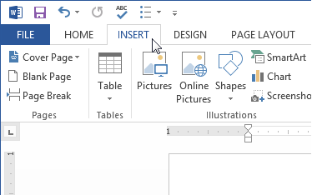

1. Click the **Object** command in the **Text** group.

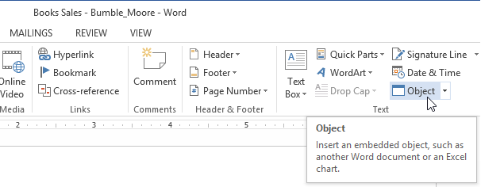

1. A dialog box will appear. Select the **Create from File** tab, then click **Browse**.

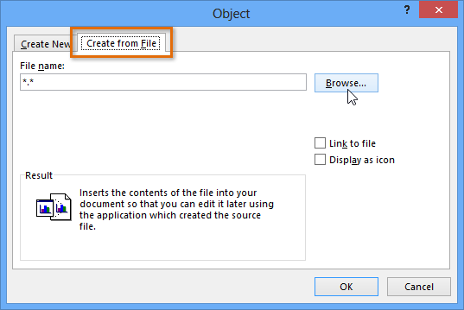

1. Locate and select the desired **Excel chart**, then click **Insert**.

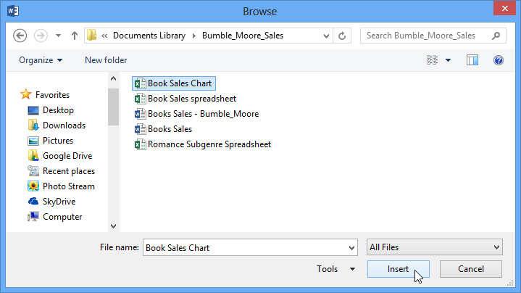

1. Check the box next to **Link to file** if you would like to **link the data** to the Excel chart. This will enable your Word chart to update itself when changes are made to the Excel chart.
2. Click **OK**.

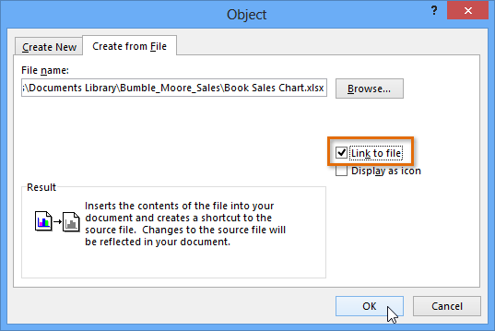

1. The chart will now appear in your Word document.

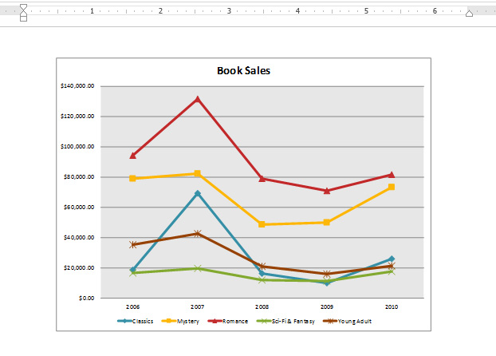

To**edit** an embedded chart, double-click the chart. An Excel spreadsheet containing the chart's source data will appear. After you have finished editing, be sure to **save**the chart in Excel.

Once you have embedded a chart, be careful not to delete or move the original Excel file. If the location of either the Word document or the Excel file changes, you may have to embed the chart again in order for it to display correctly.

